# Use Case, Pairwise and Classification Trees Testing

# Homework

1. 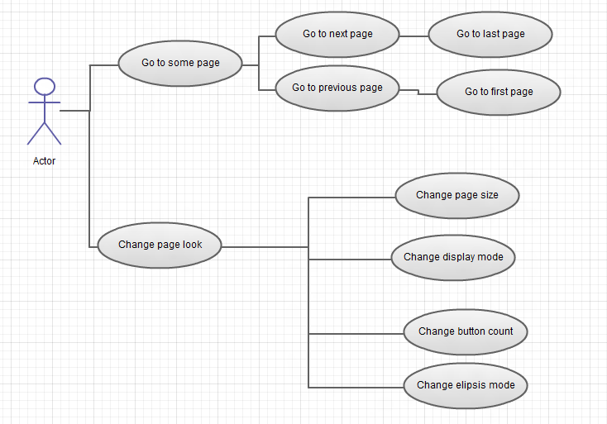Below you have a use case diagram on the DataPager control you can find on <http://demos.telerik.com/silverlight/#DataPager/FirstLook> .

Look at the diagram, go to the link and:

* Create Use Case workflows on navigating and setting the control. Create normal and exceptional workflows

1. Create pairwise table with the possible combinations

|  |
| --- |
| Browser (Firefox, IE, Chrome and versions) |
| Silverlight/WPF version(SL4, SL5, WPF 3.5, WPF4) |
| OS (Windows 7, windows 8, Linux, Mac OS) |

1. Derive and automate concrete Test Cases using Use Case Technique
2. Use the test application **RadGridView_TestSolution** (attached in Demo section)
3. As a base use a test case from the derived ones (by using PairWise or Classification Trees Techniques in class) for the properties CanUserSelect, SelectionMode and SelectionUnit of RadGridView. A concerete test scenario should be derived for a particular property values combination.

Example:

|  |  |  |  |
| --- | --- | --- | --- |
| TestCase | SelectionMode | SelectionUnit | CanUserSelect |
| 1 | Mutliple | FullRow | TRUE |

User scenario:

* Go to demo
* Set the properties to the concrete values
* Click on the first row -> The row should be selected
* Click on the second row -> Both the first and the second rows should be selected
* Click again on the first row -> The first row should not be selected, the second row should remain selected.
* …

1. Automate the test scenarios.